**Model Development Phase Template**

|  |  |
| --- | --- |
| Date | 30 June 2025 |
| Team ID | LTVIP2025TMID47084 |
| Project Title | Revolutionising Liver Care- Predicting Liver Cirrhosis using advanced Machine Learning |
| Maximum Marks | 4 Marks |

**Initial Model Training Code, Model Validation and Evaluation Report**

The initial model training code will be showcased in the future through a screenshot. The model validation and evaluation report will include classification reports, accuracy, and confusion matrices for multiple models, presented through respective screenshots. **Initial Model Training Code:**

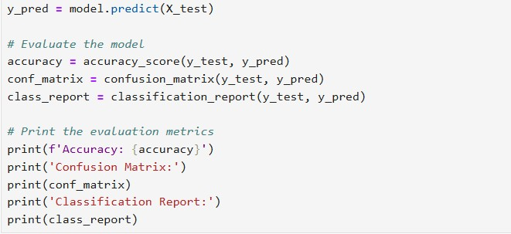

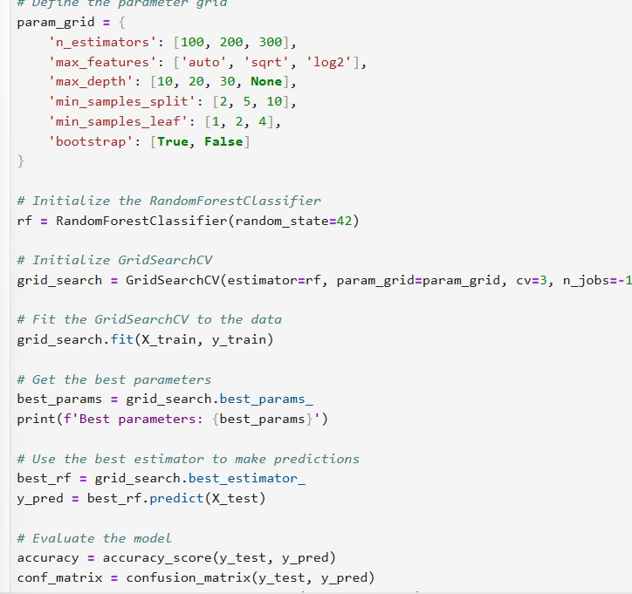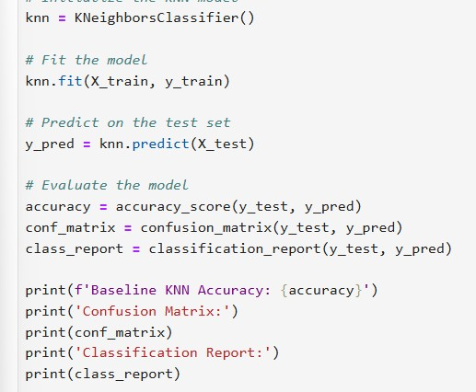

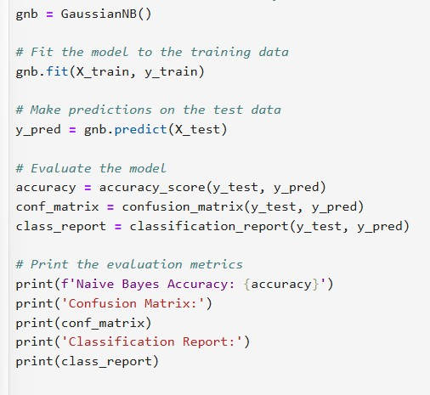

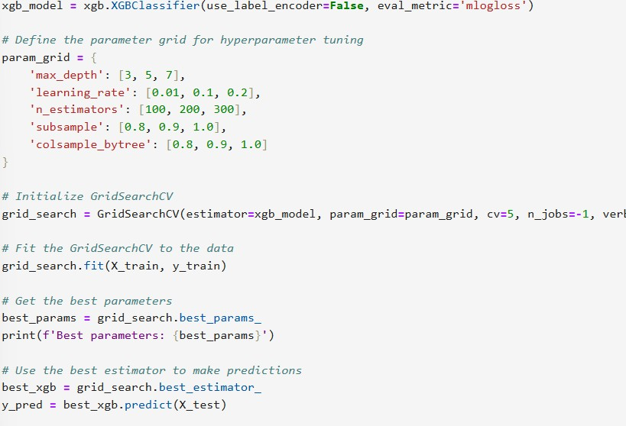

|  |  |  |  |
| --- | --- | --- | --- |
| **Model** | **Classification Report** | **F1**  **Scor e** | **Confusion Matrix** |
| Random  Forest |  | 86% |  |

**Model Validation and Evaluation Report:**

|  |  |  |  |
| --- | --- | --- | --- |
| Naïve Bayes |  | 78% |  |
| KNN |  | 89% |  |

|  |  |  |  |
| --- | --- | --- | --- |
| Xg  Boost |  | 78% |  |